PRESIDENT’S MESSAGE
By Cathie Clinch

Celebrate BC Family Day on Monday, February 13th!!!
A big Thank You to members who sold Mining For Miracles Diamond draw tickets at RoundUP to benefit BC Children's Hospital. Be sure to read Toni Wallis's recap in this issue of 'The Drift.' You know your efforts are truly appreciated by the ill children and their families.
Mark your calendars for our meeting on Tuesday, February 21st at the Lonsdale Quay.
The Quay and waterfront have changed since our last visit. Join us while we explore
new businesses, see new views and attractions in the area. If it is rainy we will warm-up inside with a no-host pub lunch at the Cheshire Cheese Restaurant.
***Note our AGM will be a luncheon on Tuesday, May 16th! More details will follow in upcoming Drift newsletters
We are looking forward to seeing you at our varied events this year. If you have a
meeting idea or suggestion, please feel free to contact me or any other Exec. Member.

PROGRAMS
Tuesday, February 21st: Lonsdale Quay

Lonsdale Quay Market is an eclectic collection of over 80 vendors, artists and crafters.

We plan the morning wandering around the Lonsdale Quay looking at various local shops like Tilley Vancouver, Tulips Children’s Ware, Saje Natural Wellness, Toy Castle, Margitta’s Flowers, Inka’s World, Celtic Creations and Allyado Leather Goods. If the weather is good, we may even wander out towards the waterfront area – bring an umbrella in case we prove to be intrepid tourists in our own city.

Lonsdale Quay Website

ATM services are available at the Quay for BMO and RBC banks.

As always, friends and husbands are always welcome to come.

We will meet on the lower floor at 10am near the stairs at the south end. From there we can wander around the quay separately, or in a group.

Lunch will be at the Cheshire Cheese Restaurant in the Lonsdale Quay, on the second floor. The Cheshire Cheese offers fresh, local and sustainable seafood, paired with traditional and contemporary British favourites as well as a wide selection of draft beer, wine and cocktails.

Cheshire Cheese Restaurant Lunch Menu

Cost: There is no cost for this event. Lunch will be by individual checks

Time: 10:00am Meet at the double stairs at the south end of the market area
11:30am Lunch at the Cheshire Cheese

Parking: 2 hours of FREE parking in the Lonsdale Quay Market parkade. Please enter your license plate number at one of the machines.

Please RSVP to Dawn Russell by February 19th.

Tuesday, March 21st: BC Sports Hall of Fame, BC Place

We have arranged a Celebrate the Hall tour of the BC Sports Hall of Fame at Gate A of BC Place Stadium, off Beatty Street between Robson and Georgia. In addition to a tour of the Hall of Fame, we hope to have a tour of the BC Place stadium (depending upon the installation of Playdome @ BC Place) that could include access to the team lockers, the premium suites and/or the media lounge

BC Sports Hall of Fame Galleries

As this is during March Break, grandchildren are welcome to attend as are friends and spouses. The tour is expected to last about 45 minutes but we are free to wander and review the stations for as long as we like. A receipt will be given that will allow re-entry privileges to those that wish to return to Hall of Fame after lunch.

Times: 10:00am Meet at the Terry Fox Statue outside BC Place
10:30am Tour of BC Sports Hall of Fame
12:00am Lunch at Frankie’s Italian Kitchen

Cost: $10.00 per person for the tour
Lunch is by individual tab

Following the tour, we will enjoy an a la carte luncheon at Frankie’s Italian Kitchen, 765 Beatty Street, just a half block away from BC Place Stadium. Please see below link for a look at the lunch menu offered.

Frankie's Italian Kitchen Lunch Menu

Getting There:
By Skytrain:
- Using the Expo Line, get off at Stadium-Chinatown Station and take the exit using the upwards stairs to Beatty Street and Dunsmuir. Exit on Beatty, walk 2 blocks south to Terry Fox Plaza.
- Along the Canada Line, disembark the Vancouver City Centre Station at Granville and Georgia. Exit on Granville, walk 1 block south, and 7 blocks east on Robson to Terry Fox Plaza.

By Car: There are three nearby parking lots to the Stadium. Please consider carpooling.
- At 858 Beatty Street is an Impark Parking lot at the Pivotal Building rates are $5.00 per hour or $12.00 daily
- At 651 Expo Boulevard is an Impark parking lot (Lot #313) beside the BC Place Stadium rates $3.00 per hour,
- At 701 Expo Boulevard is an Advanced Parking lot (Lot #9161) rate $2.50 per hour

MEMBERSHIP
By Irene Rhodes
If you have any changes to your contact information, please telephone Irene Rhodes.

PHOTOGRAPHS
If anyone has taken photographs at any of our events this past year and would like to submit them for our website photo album, please email them to Barbara Caelles.

CORRESPONDENCE
If you know of any member who has had an illness, birth, special anniversary, or other event where it would be appropriate to send a card, please call Mary Leathley.

Mining For Miracles Ticket Sales Update
By Toni Wallis

Please see below a couple of photographs of our marvelous volunteers from Mining for Miracles Ticket Sales during Roundup. It was
ANOTHER RECORD WEEK for Diamond Draw ticket sales. I wish to thank each and every one of you who came out to help.
We raised 8.2% more than last year with $9,042 being collected over the week at Roundup and Cambridge House. Well done everyone!!!
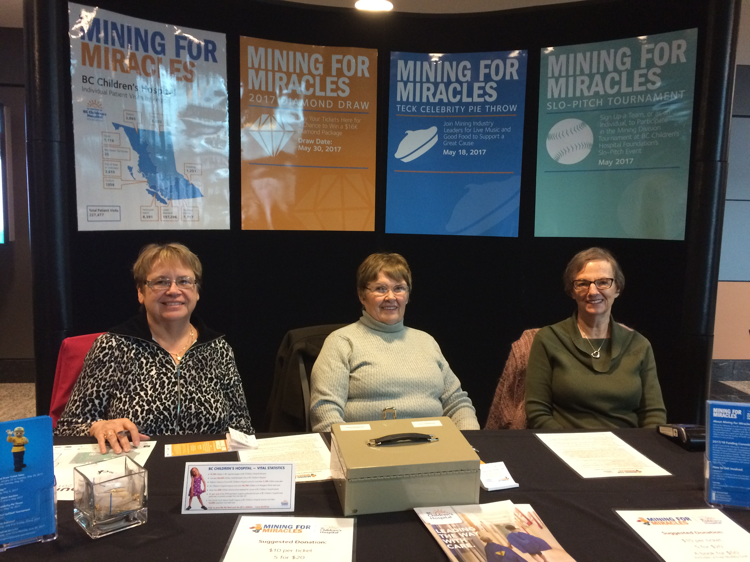
Irene Rhodes, Catherine Allan and Francis McKilligan selling tickets at the Mining For Miracles booth

We will also be selling tickets during the Teck Celebrity Pie Throw on May 18th during Mining Week and I will need a few volunteers for this. I will also have tickets for sale at the upcoming GVMWA events until May 30th if anyone did not get theirs during RoundUp.
If you can help out for the ticket sales at the Pie Throw, please give me a call.

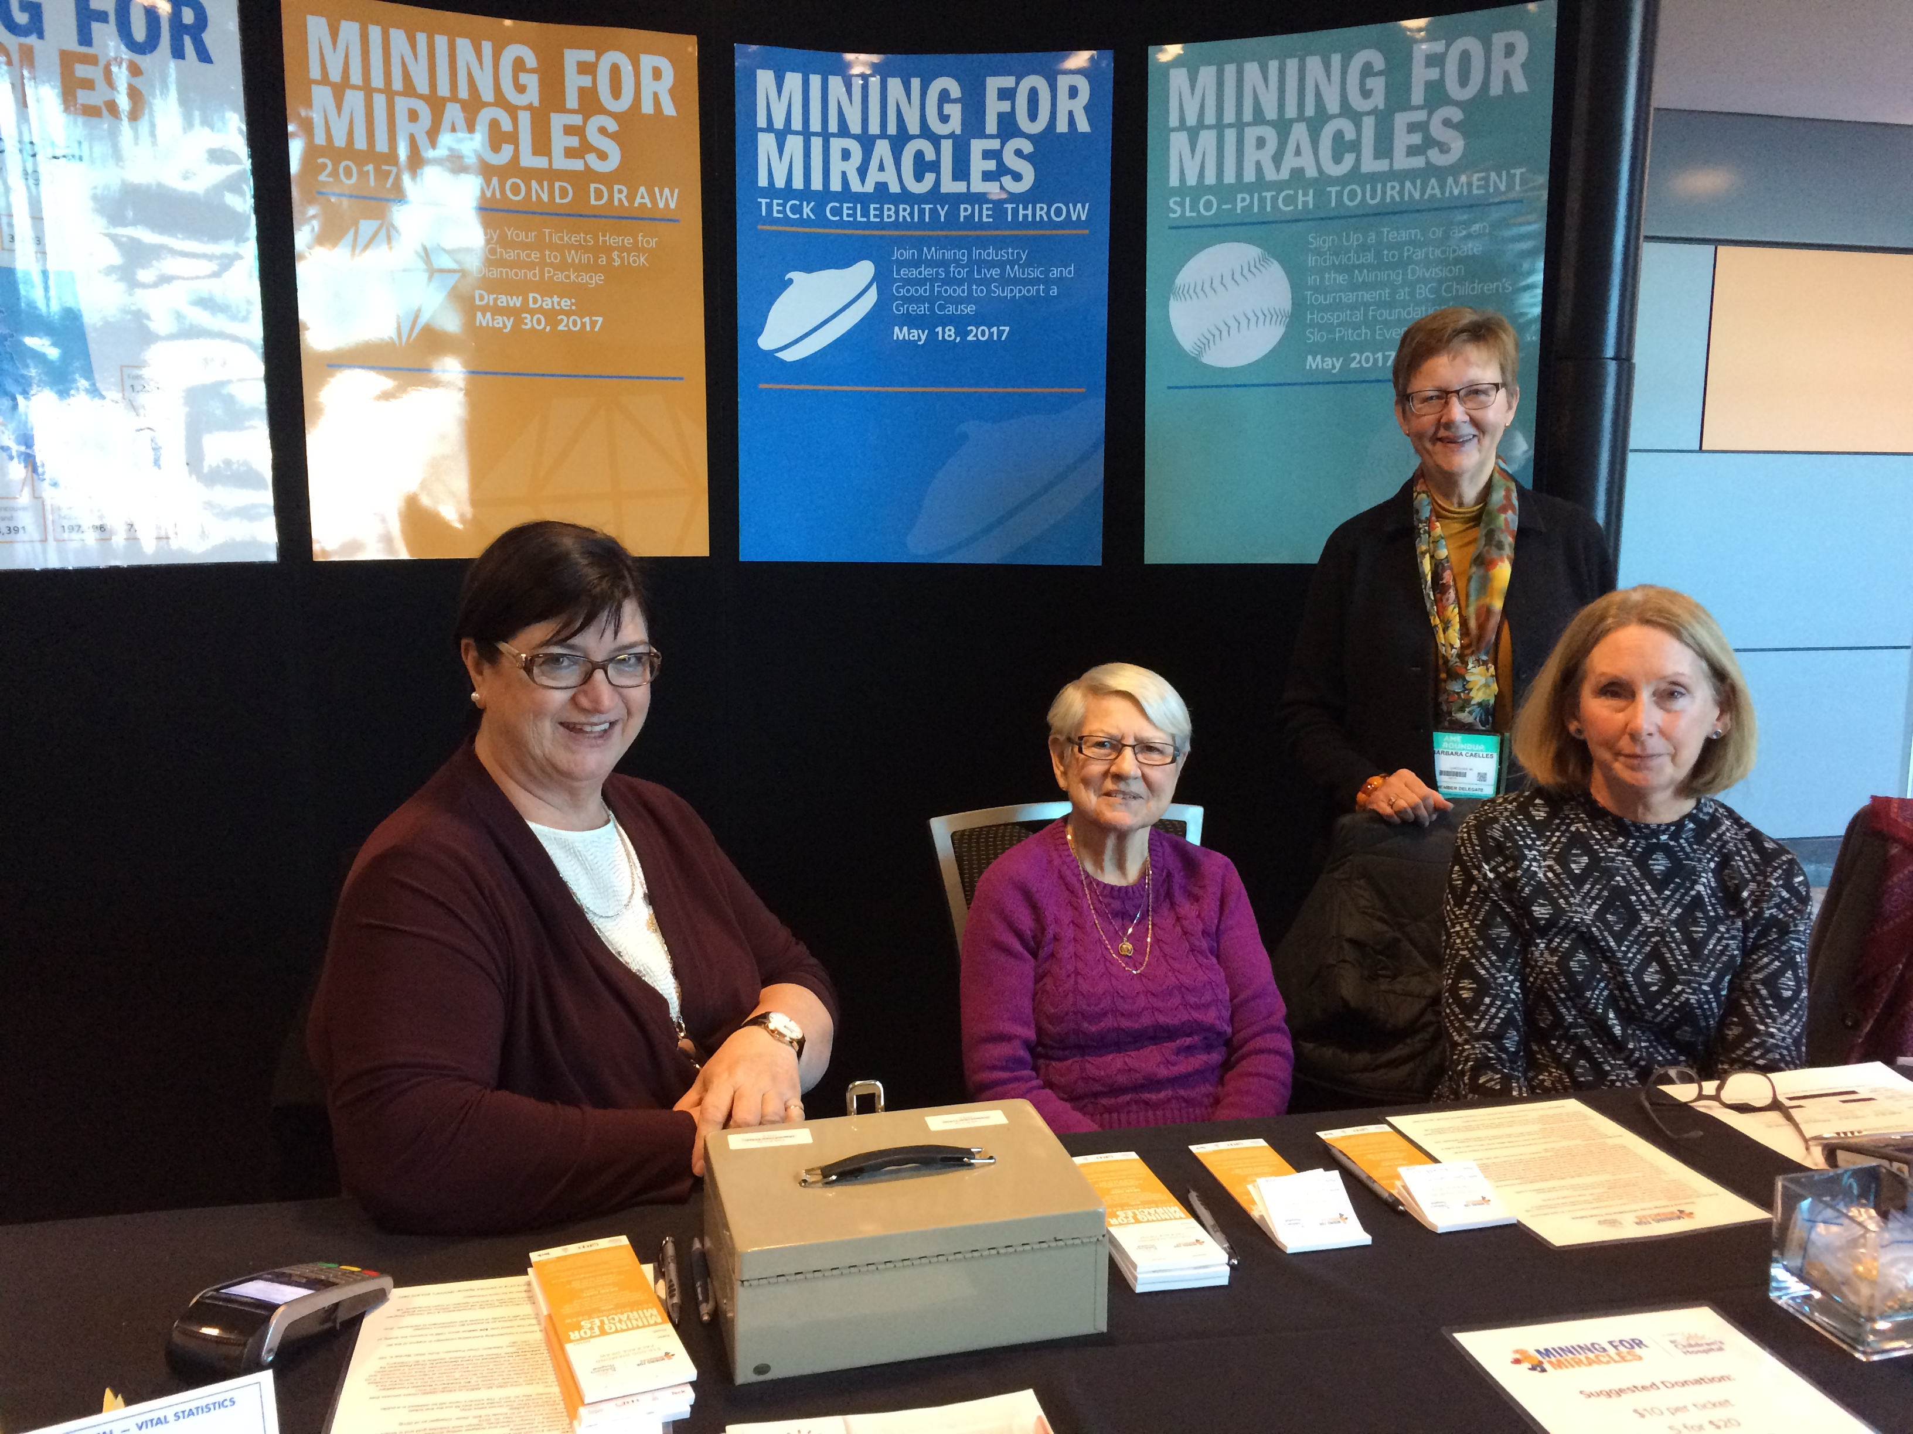
Kerry Jones, Mary Leathley, Barbara Caelles (behind) and Betty Lebel selling tickets at the Mining For Miracles booth

DATES TO REMEMBER
Feb. 21st Lonsdale Quay shopping/lunch
Mar. 21st BC Hall of Fame, BC Place
May 16th GVMWA AGM, Kings Landing Meeting Room
May 18th Teck Celebrity Pie Throw
May 30th Diamond Draw, Mining For Miracles

