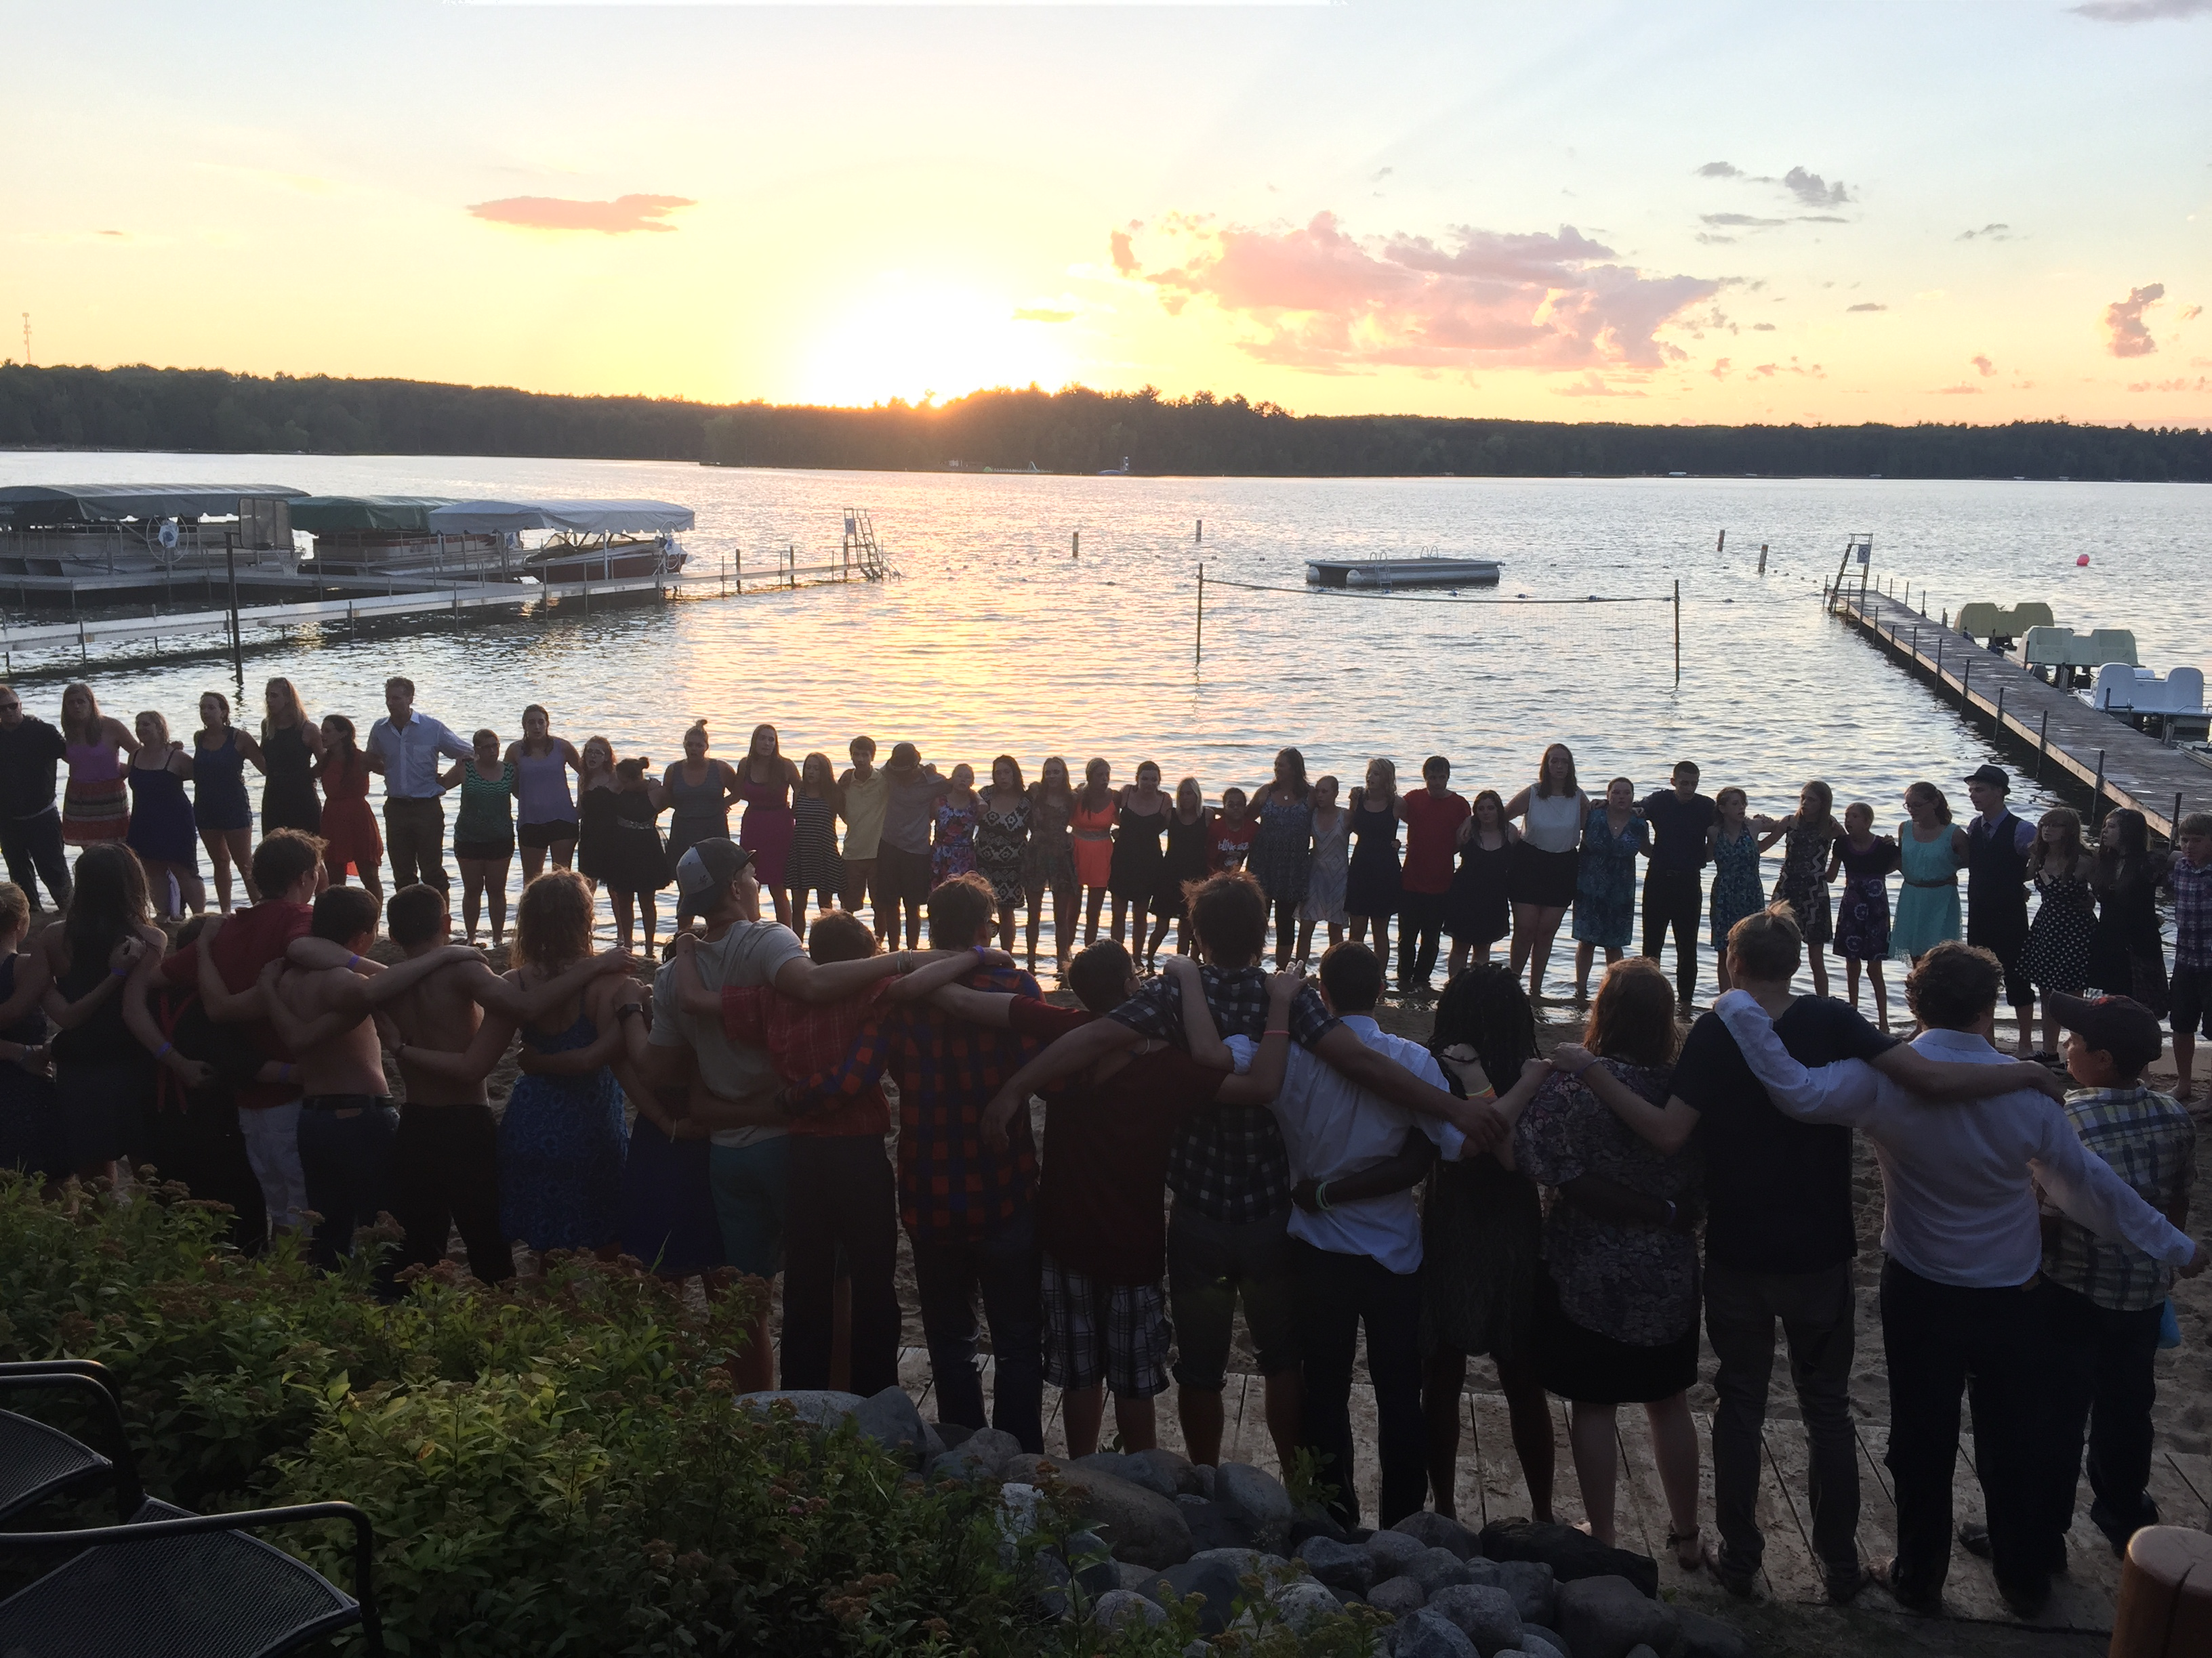
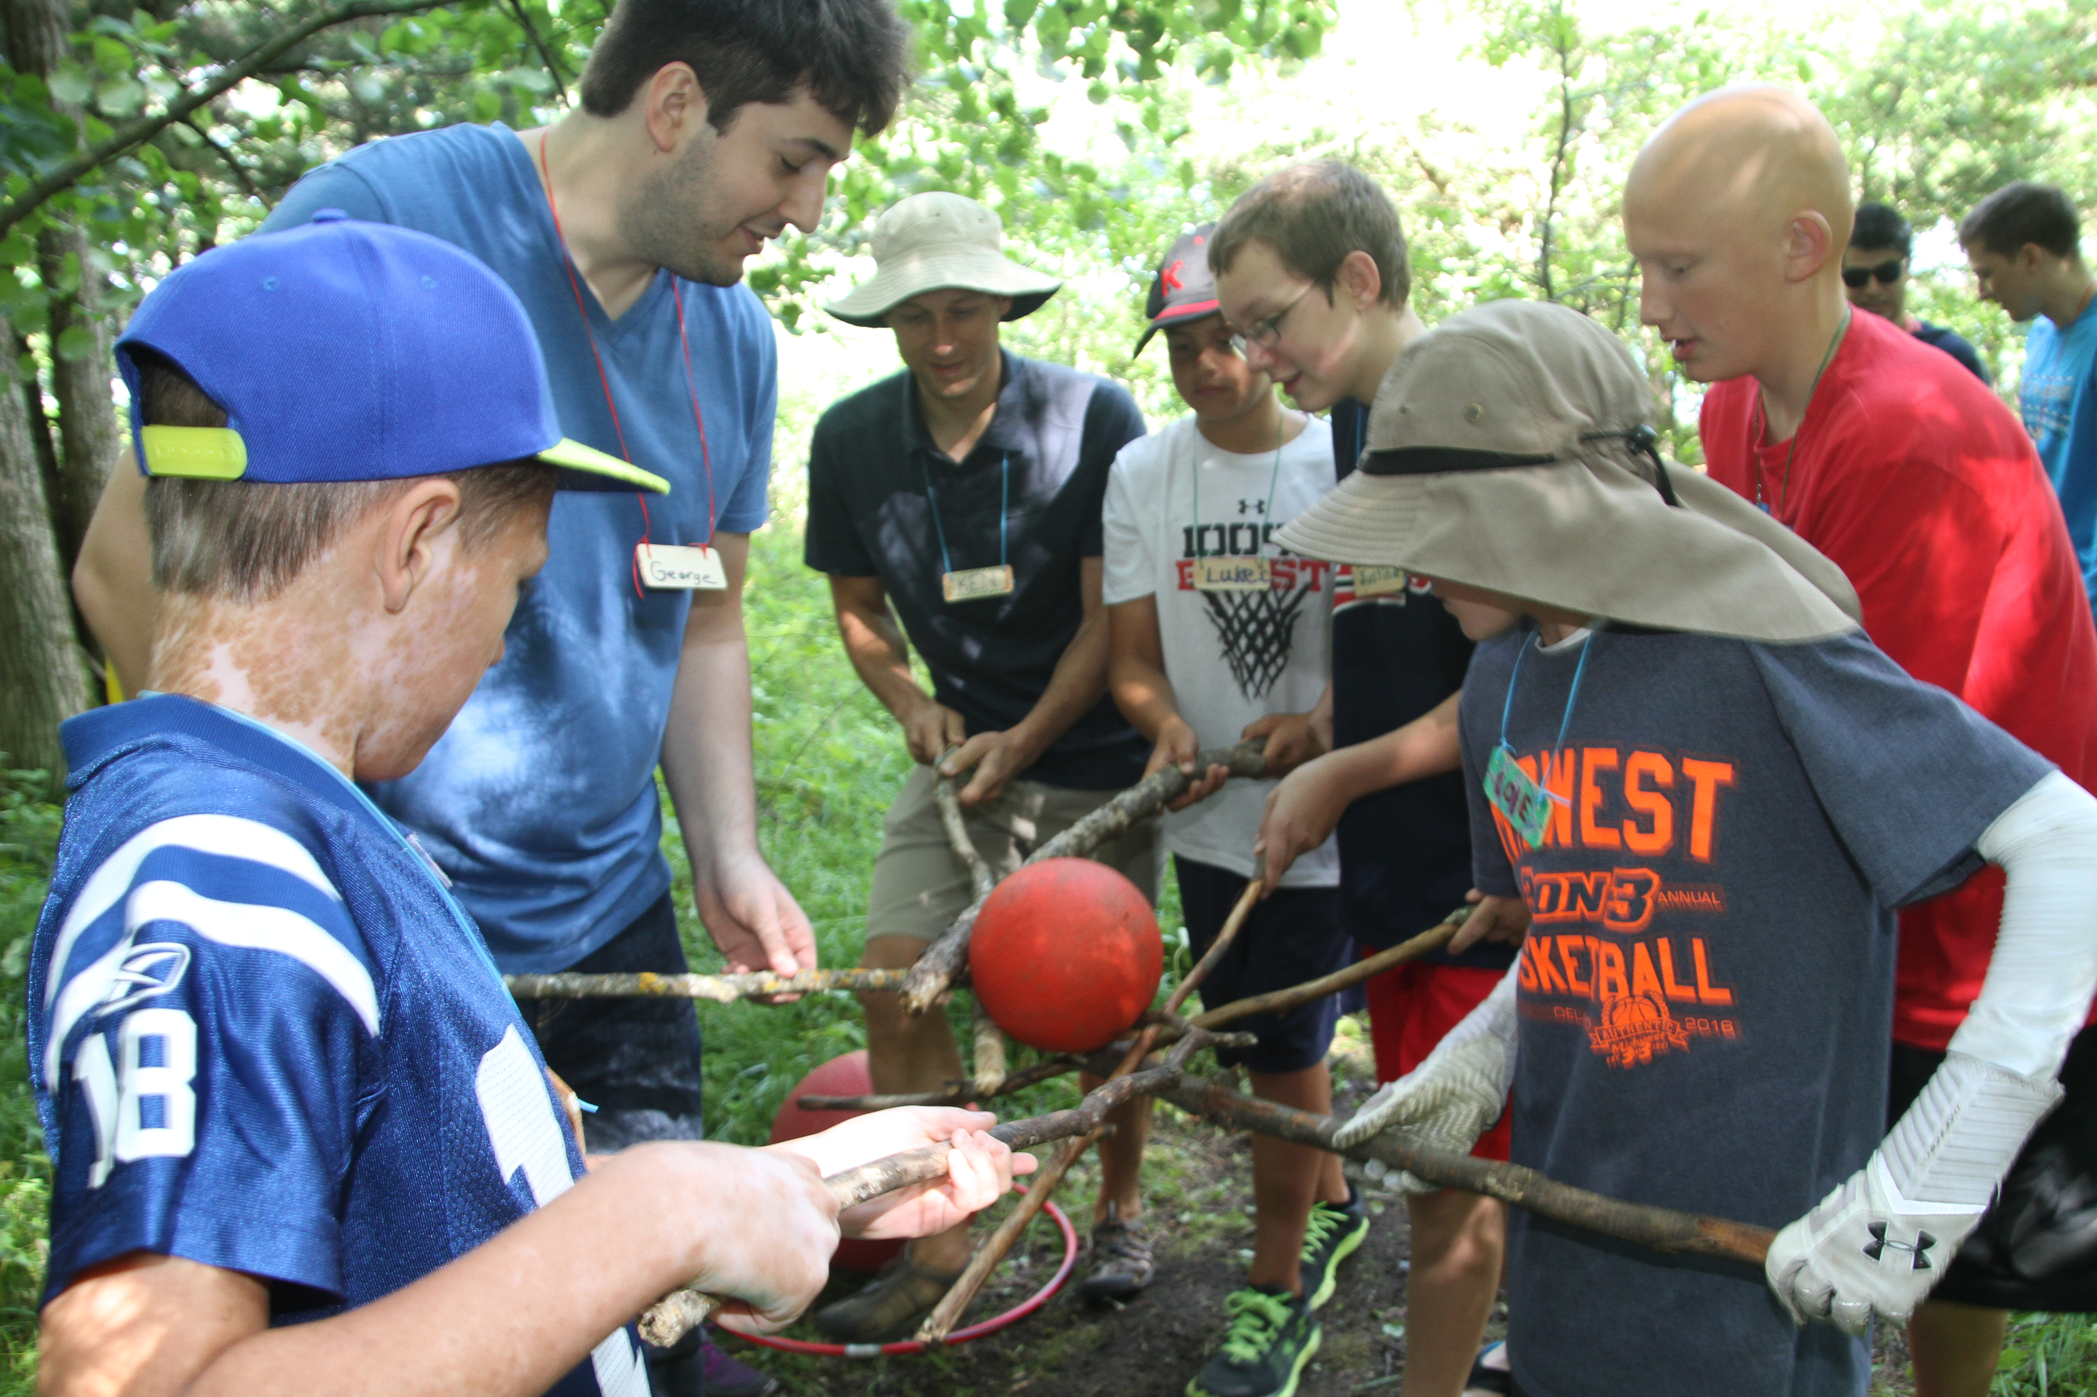
CAMP KNUTSON

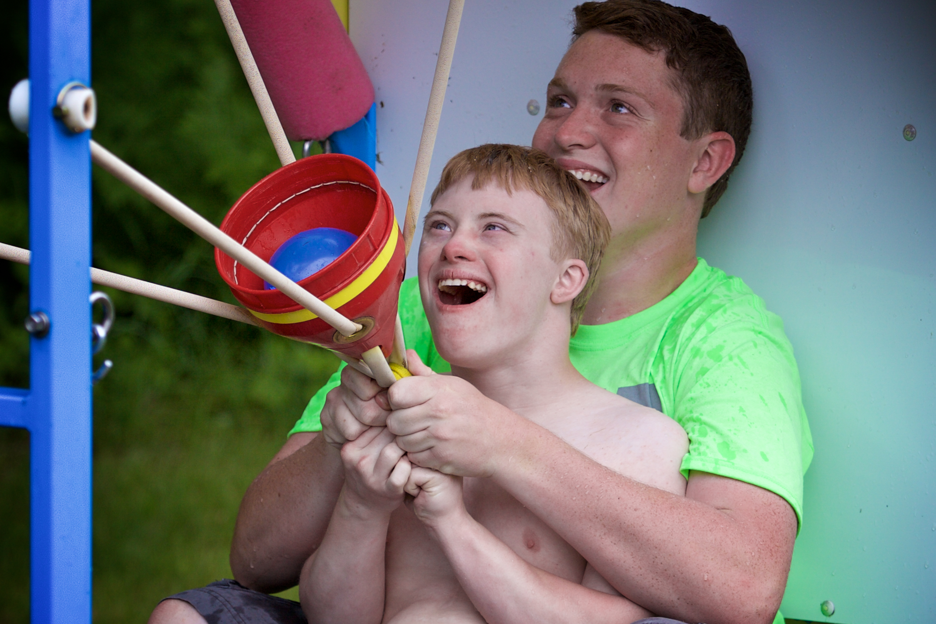

Hiring Now for 2017!!
Become a Program Specialist at Camp Knutson, where you’ll be part of a team that works with individuals with identified medical and special needs.
**We are looking for additional males to join our staff team!

Program Specialists plan and lead activities that are geared for each group of individuals with disabilities. Groups of campers change weekly and include individuals with:
*Down syndrome *Skin Disease *Autism *Heart Disease *HIV/AIDs

The summer Program Specialists must be mature, flexible, and able to contribute to and learn from the campers in an honest accepting and loving way.

Each group (week) provides their own visiting staff who are directly responsible for the campers. It is important that camp staff and visiting staff work together to provide the highest quality experience for the campers.

Summer Dates: Monday, May 22nd – Friday, August 18th
With additional extended season employment opportunities

Interested? To learn more or download application, visit:
www.campknutson.org
Application Deadline: Friday April 8th
Caitlin Malin, Program Director 608-632-4201 caitlin.malin@lssmn.org

